**SECOND TERM E-LEARNING NOTE**

**SUBJECT: TECHNICAL DRAWING CLASS: SS 3**

**SCHEME OF WORK**

**WEEK TOPIC**

1 Revision of past work.

2 Introduction to computer- parts, simple practical exercise on AutoCAD for building and mechanical drawing.

3 Architraves- semi-circular, lancet, segmental, t.udor, parabolic, elliptical, flat guage etc.

4 Architraves continued.

5 Roofs: types and structure including the plan /determination of pitch angle.

6 Conventional representation of materials and symbols.

7 Blue print.

8 Revision.

**WEEK ONE** Revision of past work

**CONTENT**

(i) General revision of past work

**WEEK TWO**Introduction to computer and simple exercises on AutoCAD

**CONTENT**

(i) Meaning and uses of a computer

(ii) Parts of a computer.

(iii) Component of a computer.

**MEANING AND USES OF A COMPUTER**

A computer is a machine that can respond to instructions and perform a list of instructions. It can store, retrieve and process data. It can be programmed with a set of instructions.

A computer can be used to type documents, send e-mail, browse the internet, handleaccounts (spreadsheet), create presentations, manage database, play games, draw graphics, just to mention just a few.

**PARTS OF A COMPUTER**

A normal desktop PC comes with the following parts or units.

1. Monitor
2. Central processing unit(Cpu)
3. Keyboard
4. Mouse
5. Speakers

**COMPONENTS OF A COMPUTER SYSTEM**

A personal computer system consists of four main components. These include

1. Hardware
2. Software
3. Data
4. Users

**EVALUATION QUESTIONS**

1. What is a computer?
2. State five parts of a computer.
3. State four components of a computer.

AutoCAD is a drawing package used for graphic constructions and designs.

There are two types of tool used in AutoCAD. These include draw tools and modify tools.

**DRAW TOOLS**

## *The line command*

Line

|  |  |  |  |
| --- | --- | --- | --- |
|  |  |  | |
|  | Rubber Band Line & Cross Hairs | | |
|  |  |  |  |

With the Line command you can draw a simple line from one point to another. You can also draw lines by entering the co-ordinates of their end points at the command prompt rather than picking their position from the screen. This enables you to draw lines that are off screen, should you want to.

Construction Line

1. **The construction line command**

The Construction Line command creates a line of infinite length which passes through two picked points. Construction lines are very useful for creating construction frameworks or grids within which to design.

Ray

1. **The Ray command**

The Ray command creates a line similar to a construction line except that it extends infinitely in only one direction from the first pick point. The direction of the Ray is determined by the position of the second pick point.

1. **The polyline command**

Polyline

The Polyline or Pline command is similar to the line command except that the resulting object may be composed of a number of segments which form a single object.

The Polyline Family

Polylines differ from lines in that they are more complex objects. A single polyline can be composed of a number of straight-line or arc segments. Polylines can also be given line widths to make them appear solid.

The illustration below shows a number of polylines to give you an idea of the flexibility of this type of line.

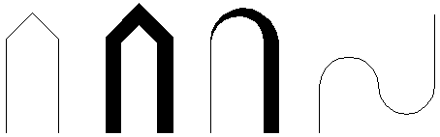

|  |  |  |  |
| --- | --- | --- | --- |
|  |  |  | |
|  |  | | |
|  |  |  |  |

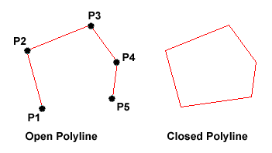

Rectangle

**5. The rectangle command**

|  |  |  |  |
| --- | --- | --- | --- |
|  |  |  | |
|  |  | | |
|  |  |  |  |

The Rectangle command is used to draw a rectangle whose sides are vertical and horizontal. The position and size of the rectangle are defined by picking two diagonal corners. The rectangle isn't really an AutoCAD object at all. It is, in fact, just a closed polyline which is automatically drawn for you.

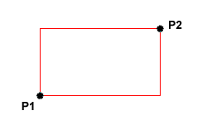

Polygon

6.  **The polygon command**

|  |  |  |  |
| --- | --- | --- | --- |
|  |  |  | |
|  |  | | |
|  |  |  |  |

The Polygon command can be used to draw any regular polygon from 3 sides up to 1024 sides. This command requires four inputs from the user, the number of sides, a pick point for the centre of the polygon, whether you want the polygon inscribed or circumscribed and then a pick point which determines both the radius of thisimaginary circle and the orientation of the polygon. The polygon command creates a closed polyline in the shape of the required polygon.

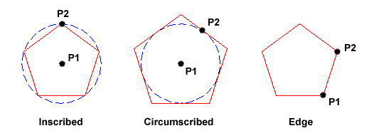

Donut

7. **The donut command**

The donut command is used to draw shapes in the form of a donut. They are constructed from single closed polylines composed of two arc esgments which have been given width.

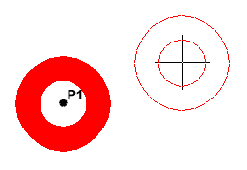

Revcloud

8. **The revcloud command**

The Revcloud command is used to draw a "freehand" revision cloud or to convert any closed shape into a revision cloud.Move the mouse to form a closed shape; the command automatically ends when a closed shape is formed.

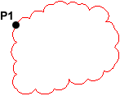

9. **The circle command**

Circle

The Circle command is used to draw circles. There are a number of ways you can define the circle. The default method is to pick the centre point and then to either pick a second point on the circumference of the circle or enter the circle radius at the keyboard.

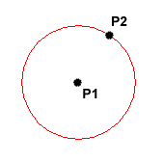

Arc

10. **The arc command**

The Arc command allows you to draw an arc of a circle. There are numerous ways to define an arc, the default method uses three pick points, a start point, a second point and an end point.

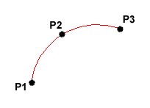

Spline

11. **The spline command**

The Spline command creates a type of spline known as a non-uniform rational B-spline (NURBS)

A spline is a smooth curve that is fitted along a number of control points.

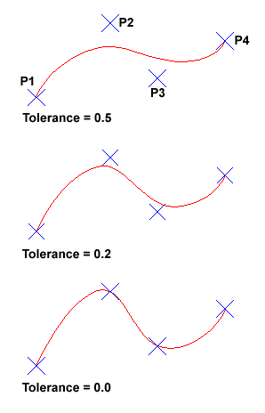

## 

12. **The ellipse command**

Ellipse

The Ellipse command gives you a number of different creation options. The default option is to pick the two end points of an axis and then a third point to define the eccentricity of the ellipse. The ellipse command can also be used to draw isometric circles.

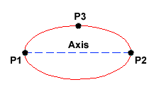

|  |  |  |
| --- | --- | --- |
|  |  |  |
|  |  | |

13. **The multilinecommand**

The Multiline command is used to draw multilines. This process of drawing is pretty much the same as drawing polylines, additional line segments are added to the multiline as points are picked. As with polylines, points can be unpicked with the Undo option and multilines can be closed.

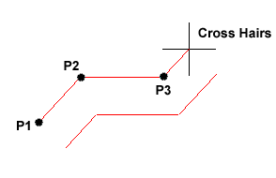

**Evaluation Questions**

1. State six types of AutoCAD draw tools.
2. Differentiate between the line command and the polyline command.

**MODIFY TOOLS**

While working with AutoCAD, you'll quickly run into situations that require you to use modify tools. As the name suggests, **modify** tools are used to modify existing lines and objects. AutoCAD has a whole range of modify tools.

[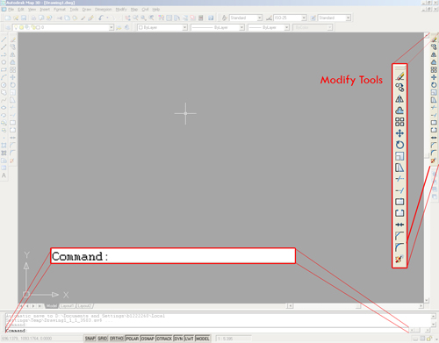](http://wiki.bk.tudelft.nl/toi-pedia/File:Modify_overzicht.jpg)

## The offset command

[Offset.png](http://wiki.bk.tudelft.nl/toi-pedia/File:Offset.png)

The **offset** command is used to create a duplicate object parallel with the original object. If this object is a Polyline or a Circle, the duplicate shape will be transformed inwards or outwards. This option can be useful to make closed steel profiles.

To offset: First select the offset distance; [enter]; select the original object; specify on which side you want to offset.

[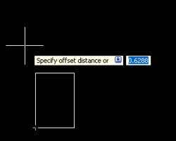](http://wiki.bk.tudelft.nl/toi-pedia/File:Modify_offset1.jpg)[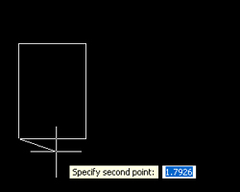](http://wiki.bk.tudelft.nl/toi-pedia/File:Modify_offset2.jpg)[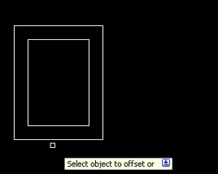](http://wiki.bk.tudelft.nl/toi-pedia/File:Modify_offset3.jpg)

[Trim.png](http://wiki.bk.tudelft.nl/toi-pedia/File:Trim.png)

## The trim command

With the **trim** option objects can be shortened or lengthened with the edges of other objects. Objects can exactly be fitted between these objects.

To trim an object: Type tr in the command line; optionally select the line(s) you want to trim (otherwise all objects are used, which is fine in most cases); [enter]; select the objects to trim.

To trim multiple objects at once you can drag a selection window.

[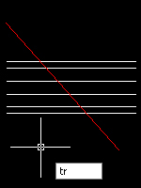](http://wiki.bk.tudelft.nl/toi-pedia/File:Modify_trim1_ok.jpg)[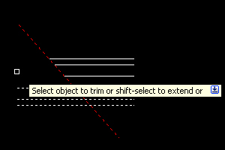](http://wiki.bk.tudelft.nl/toi-pedia/File:Modify_trim2.jpg)[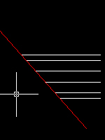](http://wiki.bk.tudelft.nl/toi-pedia/File:Modify_trim3.jpg)

[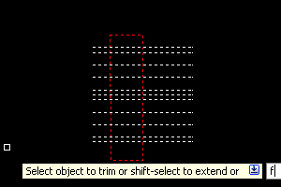](http://wiki.bk.tudelft.nl/toi-pedia/File:Modify_trim_fence4.jpg)[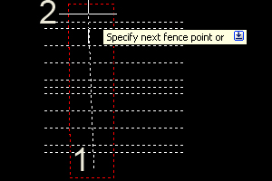](http://wiki.bk.tudelft.nl/toi-pedia/File:Modify_trim_fence5.jpg)[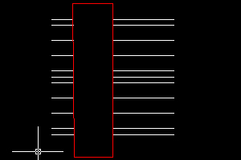](http://wiki.bk.tudelft.nl/toi-pedia/File:Modify_trim_fence6.jpg)

You might want to take a look at the fence (fe) selection option. This allows you to quickly select the lines you want to trim, by drawing a line across them. Every line that is crossed by the line you draw will be selected and trimmed.

[Extend.png](http://wiki.bk.tudelft.nl/toi-pedia/File:Extend.png)

1. **The extend command**

With the **extend** option you can shorten or lengthen objects to meet the edges of other objects. For example a line can be exactly fitted between objects. Extending a object works in the same way as trimming.

To extend: Click the Extend command; optionally select the object you want to extend to; select the line(s) you want to extend.

[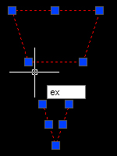](http://wiki.bk.tudelft.nl/toi-pedia/File:Modify_extend1.jpg)[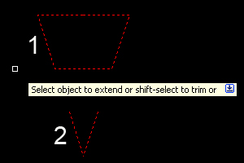](http://wiki.bk.tudelft.nl/toi-pedia/File:Modify_extend3.jpg)[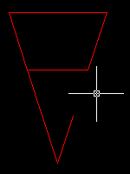](http://wiki.bk.tudelft.nl/toi-pedia/File:Modify_extend4.jpg)

[Move.png](http://wiki.bk.tudelft.nl/toi-pedia/File:Move.png)

1. **The move command**

The **move** command is used to move one or more objects from one point to another.

Select the objects and specify the base point. The base point is essentially the point where you 'grab' the objects. So if you input coordinates, the base point is the point where the coordinates relate to. Moving an object can either be done with the aid of [object snap](http://wiki.bk.tudelft.nl/toi-pedia/AutoCAD_Drawing_and_model_space#Using_OSNAP_.28object_snap.29), or by using relative coordinates.

[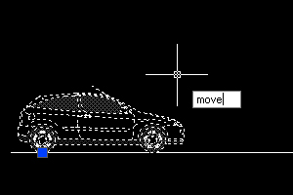](http://wiki.bk.tudelft.nl/toi-pedia/File:Modify_move1.jpg)[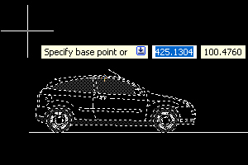](http://wiki.bk.tudelft.nl/toi-pedia/File:Modify_move2.jpg)[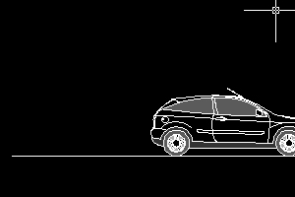](http://wiki.bk.tudelft.nl/toi-pedia/File:Modify_move3.jpg)

1. **The rotate command**

[Rotate.png](http://wiki.bk.tudelft.nl/toi-pedia/File:Rotate.png)

You can rotate objects with an absolute or relative angle. When using an absolute angle: Specify the base point and then specify the rotation angle.

[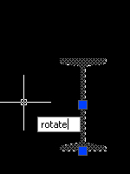](http://wiki.bk.tudelft.nl/toi-pedia/File:Modify_rotate1.jpg)[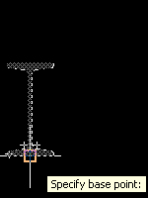](http://wiki.bk.tudelft.nl/toi-pedia/File:Modify_rotate2.jpg)[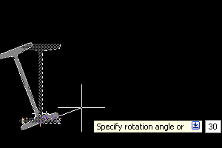](http://wiki.bk.tudelft.nl/toi-pedia/File:Modify_rotate3.jpg)[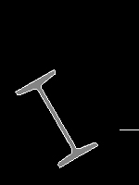](http://wiki.bk.tudelft.nl/toi-pedia/File:Modify_rotate4.jpg)

[Copy.png](http://wiki.bk.tudelft.nl/toi-pedia/File:Copy.png)

1. **The copy command**

The copy command is used to copy an object

Method: Select objects, press copy and specify a base point (in a similar way as with the move tool)

Now you can position the object in the same way as you would with a starting point of a line.

[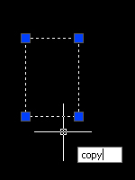](http://wiki.bk.tudelft.nl/toi-pedia/File:Modify_copy1.jpg)[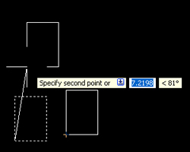](http://wiki.bk.tudelft.nl/toi-pedia/File:Modify_copy2.jpg)[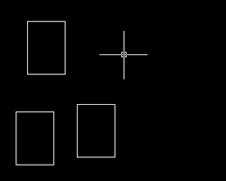](http://wiki.bk.tudelft.nl/toi-pedia/File:Modify_copy3.jpg)

1. **The array command**

[Array.png](http://wiki.bk.tudelft.nl/toi-pedia/File:Array.png)

The **array** command is used to create copies of objects in a rectangular or polar pattern. This is especially useful when you need to duplicate several objects at the same distance from each other (columns in a parking garage for instance).

After clicking on the array button the following screen will appear:

[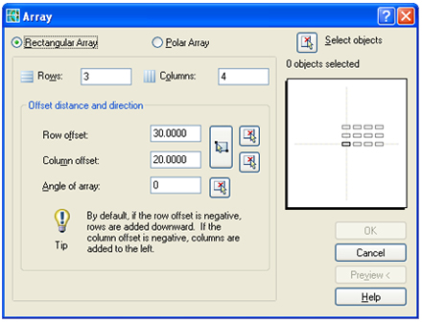](http://wiki.bk.tudelft.nl/toi-pedia/File:Modify_array_menu.jpg)

In this screen we need to input the number of Rows (horizontal direction) and Columns (vertical direction) and their respective offset. For example, to create a grid of I-beams, lets first input the number of rows and columns (in this case 3 and 4). Now input the row and column offset: 30 units to the right and 20 units upward.

AutoCAD automatically shows a preview of the array operation in the white square, try experimenting with different values (for instance a negative value instead of a positive one) to see what happens.

When you're satisfied with the settings, select the object to use in the row operation, by first clicking on the 'Select Objects' button and then on the objects themselves. Finish the selection by pressing [space] or [enter]

[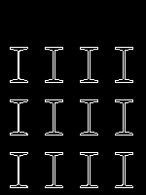](http://wiki.bk.tudelft.nl/toi-pedia/File:Modify_array2.jpg)

[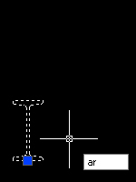](http://wiki.bk.tudelft.nl/toi-pedia/File:Modify_array1.jpg)

When the array window reappears, select either Preview or OK to execute the array command.   
In the same manner it's possible to create a polar array:

[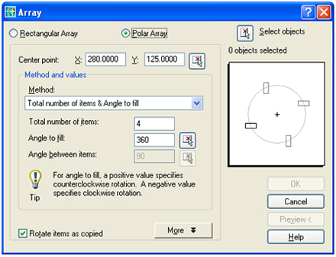](http://wiki.bk.tudelft.nl/toi-pedia/File:Modify_array_menu2.jpg)

The polar array rotates around the center point which you can select by clicking on the center point button in the array window.

[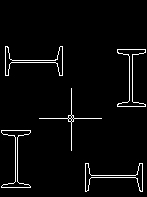](http://wiki.bk.tudelft.nl/toi-pedia/File:Modify_array4.jpg)

[Mirror.png](http://wiki.bk.tudelft.nl/toi-pedia/File:Mirror.png)

1. **The mirror command**

The mirror command is used to create a mirror image of an object. It is useful for creating symmetrical objects because you can quickly draw half the object and then mirror it instead of drawing the entire object.

You flip the object about an axis called a mirror line to create a mirror image. First select the object. To specify the temporary mirror line, you enter two points. You can choose whether to delete [y] or retain the original [n] object.

[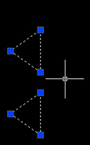](http://wiki.bk.tudelft.nl/toi-pedia/File:Modify_mirror1.jpg)[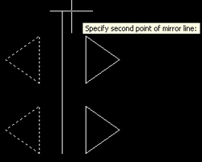](http://wiki.bk.tudelft.nl/toi-pedia/File:Modify_mirror2.jpg)[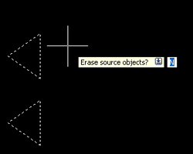](http://wiki.bk.tudelft.nl/toi-pedia/File:Modify_mirror3.jpg)[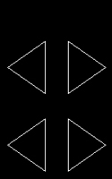](http://wiki.bk.tudelft.nl/toi-pedia/File:Modify_mirror4.jpg)

[Scale.png](http://wiki.bk.tudelft.nl/toi-pedia/File:Scale.png)

1. **The scale command**

The**scale**command is used either to enlarge or reduce an object. You can start by specifying a base point and a length which will give a scale factor. A scale factor greater than 1 enlarges the object. It is also possible to scale an object using a reference object. This method scales the object equally in all directions.

Scaling using a scale factor: Select the object; type sc in the command line; scale factor; [enter]

Scaling using a reference: Select the object; type sc in the command line; specify base point; choose r to use reference; specify the reference length of the original object; specify the new length of the original object.

[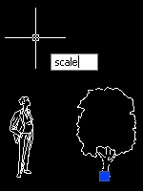](http://wiki.bk.tudelft.nl/toi-pedia/File:Modify_scale1.jpg)[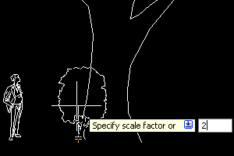](http://wiki.bk.tudelft.nl/toi-pedia/File:Modify_scale2.jpg)[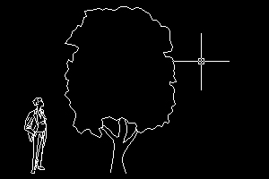](http://wiki.bk.tudelft.nl/toi-pedia/File:Modify_scale3.jpg)

[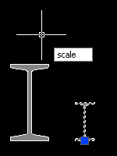](http://wiki.bk.tudelft.nl/toi-pedia/File:Modify_scale4.jpg)[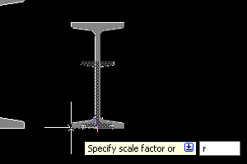](http://wiki.bk.tudelft.nl/toi-pedia/File:Modify_scale5.jpg)[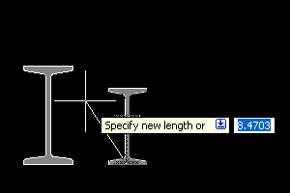](http://wiki.bk.tudelft.nl/toi-pedia/File:Modify_scale6.jpg)

[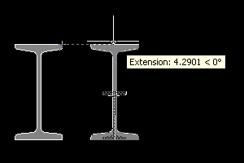](http://wiki.bk.tudelft.nl/toi-pedia/File:Modify_scale7.jpg)

[Fillet.png](http://wiki.bk.tudelft.nl/toi-pedia/File:Fillet.png)

1. **The fillet command**

You can use the **fillet** tool to connect two objects with an arc with a specified radius. The inside corner is called a fillet and an outside corner is called a round.

To fillet: type f in the command line; type R for the radius (optional); specify the radius; [enter]; select the first line; select the second line.

[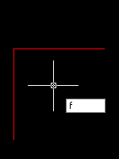](http://wiki.bk.tudelft.nl/toi-pedia/File:Modify_fillet1_ok.jpg)[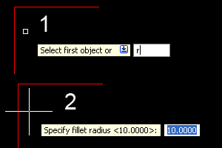](http://wiki.bk.tudelft.nl/toi-pedia/File:Modify_fillet2_ok.jpg)[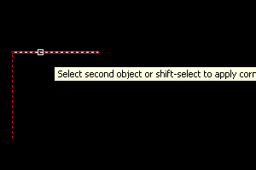](http://wiki.bk.tudelft.nl/toi-pedia/File:Modify_fillet3_ok.jpg)[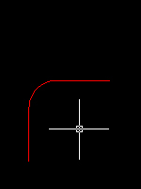](http://wiki.bk.tudelft.nl/toi-pedia/File:Modify_fillet5.jpg)

Chamfer is almost identical, but it will will make a straight line instead of an arc.

[Join.png](http://wiki.bk.tudelft.nl/toi-pedia/File:Join.png)

1. **The Join command**

The **join** tool can be used to combine similar objects into one single object. It is also possible to create complete circles from arcs.

The object you want to join is called the source object. And the objects you want to join have to be located in the same plane.

To join: Type j in the command line; select the source object; select the lines to join to the source object.

[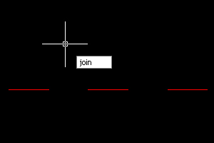](http://wiki.bk.tudelft.nl/toi-pedia/File:Modify_join1.jpg)[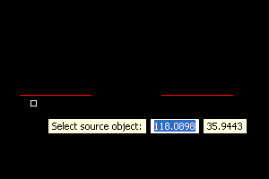](http://wiki.bk.tudelft.nl/toi-pedia/File:Modify_join2.jpg)[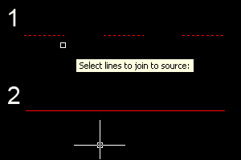](http://wiki.bk.tudelft.nl/toi-pedia/File:Modify_join3.jpg)

If you use AutoCAD 2009 or older, you can only join lines when the endpoints of the lines are on one point.

[Explode.png](http://wiki.bk.tudelft.nl/toi-pedia/File:Explode.png)

1. **The explode command**

Polylines, hatches or blocks can be converted into individual elements with the explode option.

If you explode a polyline, every segment will become a separate line.

To Explode a block: First select the block; type ex; [enter].

[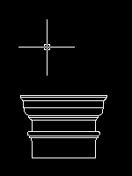](http://wiki.bk.tudelft.nl/toi-pedia/File:Modify_explode1a.jpg)[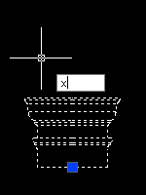](http://wiki.bk.tudelft.nl/toi-pedia/File:Modify_explode1.jpg)[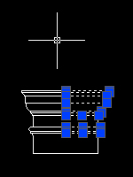](http://wiki.bk.tudelft.nl/toi-pedia/File:Modify_explode3.jpg)[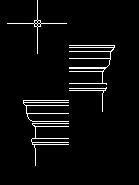](http://wiki.bk.tudelft.nl/toi-pedia/File:Modify_explode2.jpg)

**General evaluation questions**

1. State six types of modify tools
2. Differentiate between fillet and chamfer.
3. State four types of computer component.
4. Describe the step you will undergo in using fillet tool to draw an elbow.

**Reading assignment**

1. Use [www.google.com](http://www.google.com) to search.

2. Use [www.google.com](http://www.google.com) to search AutoCAD

**Weekend Assignment**

**Objective**

1. The part of a computer that displays the result of the processed data is called A. input unit. B. output unit.

C. control unit. D. ALU.

[Offset.png](http://wiki.bk.tudelft.nl/toi-pedia/File:Offset.png)

1. The command tool shown above is called A. fillet. B. trim. C. line. D. offset.
2. ……………………is used for storing data to be processed and the instruction for processing. A. Memory.

B. Control. C. Output. D. CPU.

Polyline

1. The draw tool shown above is calledA. polyline. B. rectangle. C. array. D. arc.
2. The following are examples of modifying tools except A. extend. B. fillet. C. spline. D. mirror

**Theory**

1. Differentiate between modify and draw tools.
2. Draw a cube of side 50mm using AutoCAD package

**WEEK THREE**

**Topic:** Construction of Arches: Semi-elliptical, Segmental, Semi-circular.

**Content:**

(i) Meaning of arch.

(ii) Typical structure of an arch.

(iii)Types of arch and construction e.gSemi-elliptical, Segmental, Semi-circular.

Meaning of an arch

An arch could be defined as a curved structure that is supported by straight sides sometimes created in wall openings such as doors or windows of a building. In buildings, arches act as lintel because they have the ability to support the weight of blocks and other materials placed upon them.

Typical structure of an arch

A typical structure of a semi-circular arch consist in addition to the crown which is the highest point of the arch the intrados, extrados, rise, clear span, keystone, inpost,voussoir, abutment and run. See diagram below for a typical structure of a semi-circular arch.

THE STRUCTURE OF A SEMI-CIRCULAR ARCH

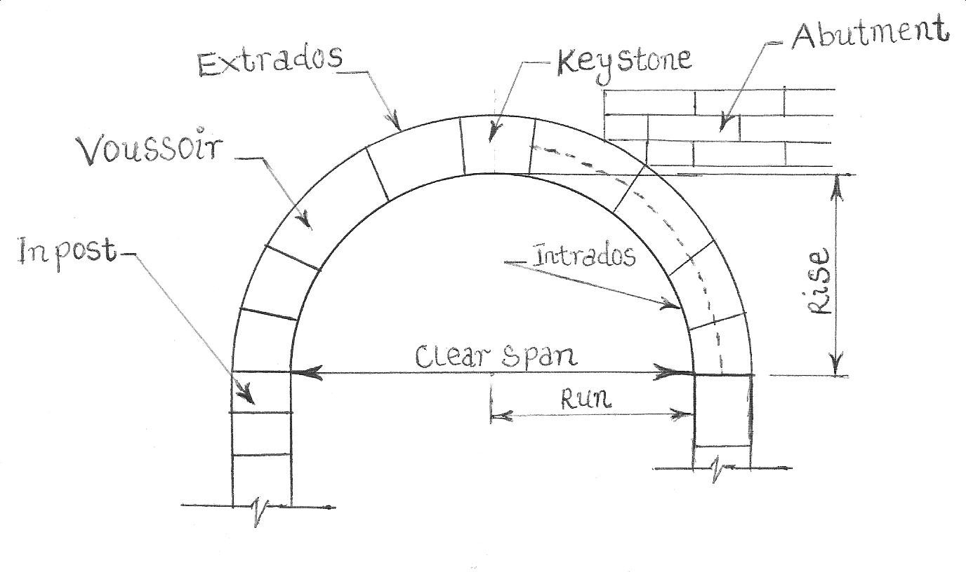

Evaluations

1. What is an arch?

2. Draw a typical structure of a semi-circular arch.

Types of arch and construction e.gSemi-elliptical, Segmental, Semi-circular.

1. **Semi-elliptical**:

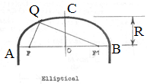

**Method of construction**: To construct an elliptical arch when given the major axis(span) AB and the minor axis.

R is half the given minor axis.

Draw a line AB equal in length to the given major axis.

Locate the mid-point O on line AB. Draw a perpendicular OC at O equal in length to half the given minor axis. Note: Minor axis is by formulae half of the Major axis.

With C as centre and radius equal to half the major axis, draw an arc to locate the positions of the focal points F and F1.

With F1 as centre and radius F1F, draw an arc. Then with F as centre and radius equal to twice F1B, draw another to intersect the previous one at point Q. Repeat the same procedure to get the remaining points. Join the points together with a French curve to obtain the required arch.

2. **Segmental**: As the name implies, this type of an arch has the shape of the segment of a circle.

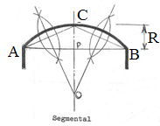

**Method of construction**: To construct a segmental arch when given the span AB and rise R.

Draw a line AB equal in length to the given span.

Draw the bisector of line AB.

Mark off the rise R on the bisector to get point C.

Join AC and BC.

Draw the bisector of lines AC and BC respectively to get point O.

With O as centre and radius OB or OA, draw the required segmental arch.

3. **Semi-circular**: This type of arch is semi-circular in shape; hence the name.

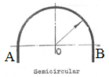

**Method of construction:** To construct a semi-circular arch when given the span AB.

Draw a line AB equal to the length of the given span.

Locate the mid-point O.

With O as centre and radius OB or OA, draw a semi-circle.

**Evaluations**

1. Sketch the diagram of a semi-elliptical arch.

2. Construct a segmental arch whose span and rise are respectively 100 and 35.

**Reading assignment**

1. Technical drawing by J.N Green page 133.

2. Use [www.google.com](http://www.google.com) to search for types of arches.

**Weekend Assignment**

**Objective**

The figure below shows a semi-circular arch. Use it to answer questions 1 to 3.

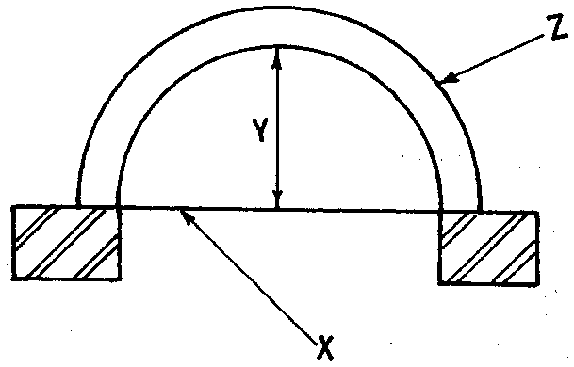

1. The part labelled**X** is called the A. springing line. B. span. C. base line. D. crown.

2. The distance labelled**Y** is the A. depth. B. rise. C. thickness. D. span.

3. The part labelled**Z** is the A. crown. B. springing line. C. intrados. D. extrado.

4 Keystone is not a characteristics of the following except stair. B. arch. Roof.Foundation.

5. The inner part of a semi-circular arch is called A. span. B. crown. C. intrados. D. run.

**Theory**

1. Sketch a segmental arch.

2. Draw a detailed structure of a semi-circular arch.

**WEEK FOUR**

**Topic:**  Construction of Arches: Tudor, Equilateral gothic, Lancet and Parabolic.

**Content:**

(i) Construction of tudor, equilateral gothic, lancet and parabolic arches respectively.

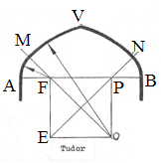

1. **Tudor**:

**Method of construction**: To construct a tudor arch when given the span.

Draw a line AB equal in length to the given span.

Divide AB into 4 equal parts.

Construct a square on the length between the 1st and 3rd divisions ie FPOE.

Draw the diagonals of the square which form common normal to the curves that trace out arch. ie with F as centre and radius FA, draw an arc AM. Then with O as centre and radius OM, draw arc MV. Repeat same with centre P and E respectively to complete the arch.

2. **Equilateral Gothic**: As the name implies, it is an arch formed by two slant sides of an equilateral triangle.

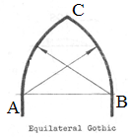

**Method of construction:** To construct an equilateral gothic arch when given the span AB.

Draw a line AB equal in length to the given span.

With A as centre and radius AB, draw an arc on the slant side AC.

With B as centre and radius BA, draw an arc on the slant side BC to meet the former arc at point C.

3. **Lancet**: Lancet arch is similar to equilateral gothic in construction except that it tapers more at the crown than

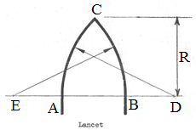

equilateral gothic.

**Method of construction:** To construct a lancet arch when given the span AB and rise (height) R.

Draw a line AB equal in length to the given span.

Extend line AB to point D by an amount equal to R/2 .

Extend line BA to point E by an amount equal to R/2 .

With E as centre and radius EB, draw an arc.

Similarly, with D as centre and radius DA, draw another arc to intersect the previous one at point C. The arc produced is lancet.

4. **Parabolic:** Parabolic arches have the shape of parabolas. Construction method (WEEK 4 of 3RD TERM SS1)

**General evaluations**

1. Construct a Tudor whose span is 80.

2. Construct a lancet arch whose span and rise are respectively 50 and 40.

3. Sketch 5 types of arches.

**Reading assignment**

1. Technical drawing by J.N Green page 133.

2. Use [www.google.com](http://www.google.com) to search for types of arches

**Weekend Assignment**

**Objective**

1. The highest point of an arch is called A. peak. B. apex. C. crown. D. head.

2. Which of the following is not a type of arch? A. Spiral. B. Segmental. C. Semi-elliptical. D. Semi-circular.

3. Which of the following cannot be used in a window opening? A. Arch. B. Lintel. C. Column. D. Beam.

4. The inner wall of an arch is called A. extrados. B. intrados. C. abutment. D. rise.

5. The vertical height of an arch is called A. keystone. B. rise. C. crown. D. run.

**Theory**

1. Draw and label a typical structure of a semi-circular arch.

2. Sketch the following arches (a) equilateral gothic. (b) semi-elliptical.

**WEEK FIVE**

**Topic**: Roofs: Flat, Pitched, Gable, Butterfly, Lean-to, collar, hip etc.

**Content:**

(i) Meaning and types of roof.

(iii) Development of a roof.

**Meaning and types of roof.**

Roofs are building structures that provides covering for the entire building and protects any internal decoration or fittings from the weather and thereby rendering the house habitable.

Roofs are basically classified into two types and these include flat and pitched roofs respectively. There are different kinds of roof today but we are going to emphasize only the most common ones found around and these include: Gambrel, Shed, Hip, Butterfly, Gable, Flat, Monitor, Half monitor, Arched, Combination, Lean-to, Collar and Mansard roof respectively. See diagrams below for different types of roof.

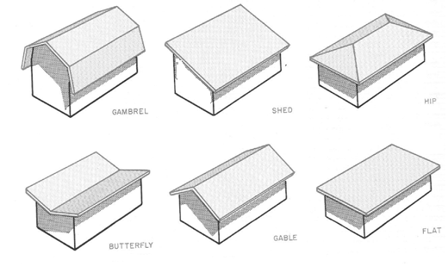

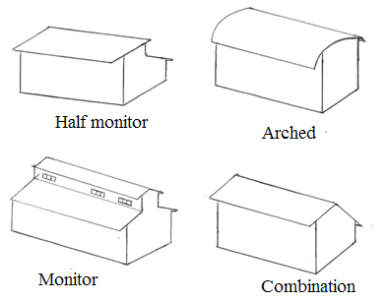

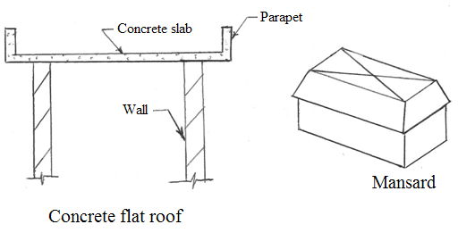

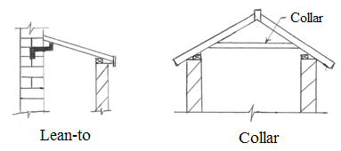

**Evaluations**

1. Define a roof.

2. State 7 types of roofs known to you.

3. Sketch butterfly, gable, hip, shed, monitor and lean-to roofs.

**Development of a roof e.g Hip roof.**

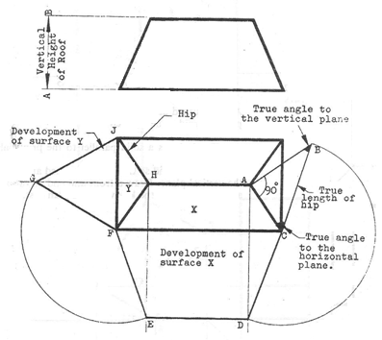

**Method**:

(i) Draw the front elevation and the plan view of the hip roof.

(ii) Take the vertical height AB, of the roof and draw it perpendicular to the plan of a hip as shown.

(ii) Join BC; this is the true length of the hip AC.

(iv) Draw perpendiculars to CF from points A and H respectively.

(vi) With C as centre and radius CB, swing an arc to cut the perpendicular from A at D. Draw a line from D parallel to CF to cut the perpendicular from H at E. Join FE. This is the development of surface X.

With F as centre and radius FE, swing an arc to cut AH produced at G. Join FG and GJ. FJG is the development of

surface Y.

**Evaluation**

1. Draw the development of the hip roof shown below

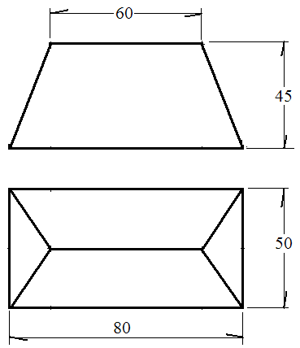

**Deyermination of the pitch angle of a roof**

The pitch angle of a roof has to do with its slope.

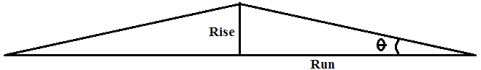

**Pitch angle ϴ = $\frac{Rise}{Run}$**

**General evaluation questions**

1. State 7 types of roofs known to you.

2. Sketch butterfly, gable, hip, shed, monitor and lean-to roofs.

3. What is a parapet ?

4. Draw a lean-to roof.

**Reading assignment**

Technical drawing by J.N. Green page 109.

Google types of roof and the determination of pitch angle.

**Weekend Assignment**

**Objective**

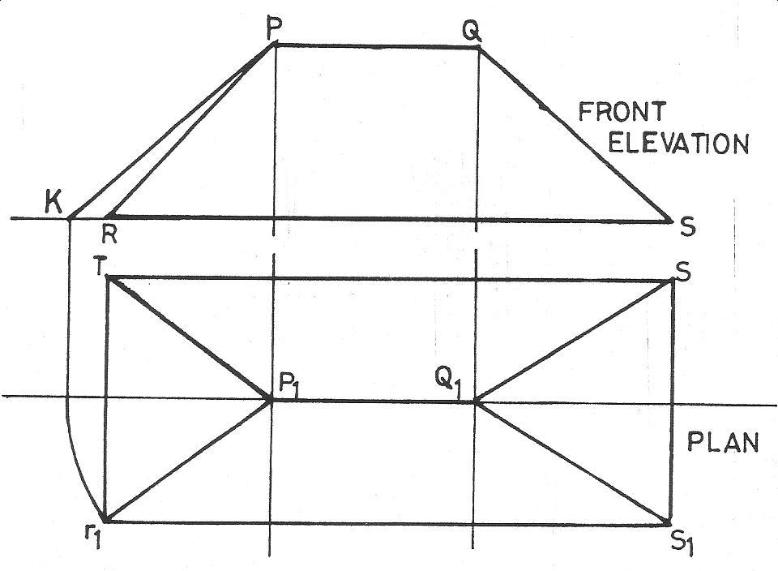

1.

The figure above shows the front elevation and plan of a hipped roof. The true length of the hip rafter is represented by line A. Q1S1 B. KP C. PR D. QS.

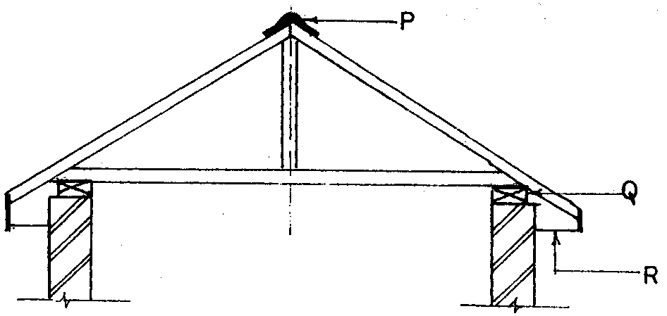

2.

In the figure shown above, the roof members P,Q and R are A. ridge cap, wall plat and eave. B. ridge cap, wall plate and king post. C. wall plate, king post and facial board. D. wall plate, ridge cap, and king post.

3. Identify the type of roof shown below. A. Lean-to. B. Butter-fly. C. Hipped. D. Domed

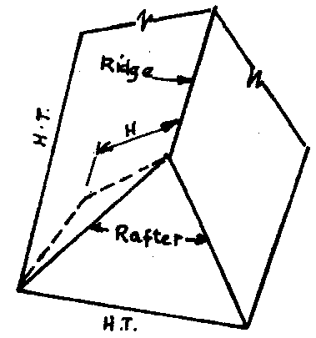

4. The type of roof shown below is called A. gable. B. hip. C. butter-fly. D. lean-to.

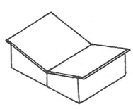

5. The type of roof shown below is called A. gable. B. shed. C. collar. D. lean-to.

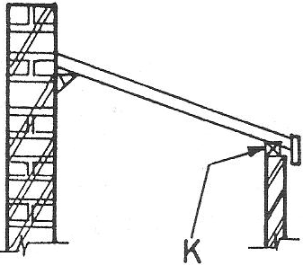

**Theory**

1. Sketch the following types of roof: butterfly, gable, hip, shed, monitor and lean-to roofs.

2. Draw the development of the hip roof shown below



**WEEK SIX**

**Topic: Conventional representation of materials/ Abbreviations.**

**Content:**

(i) Engineering material symbols

**Materials symbol**

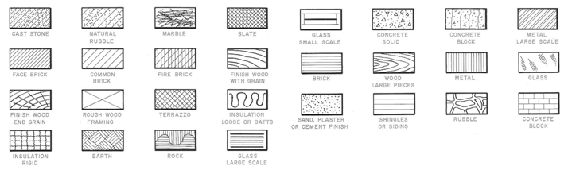

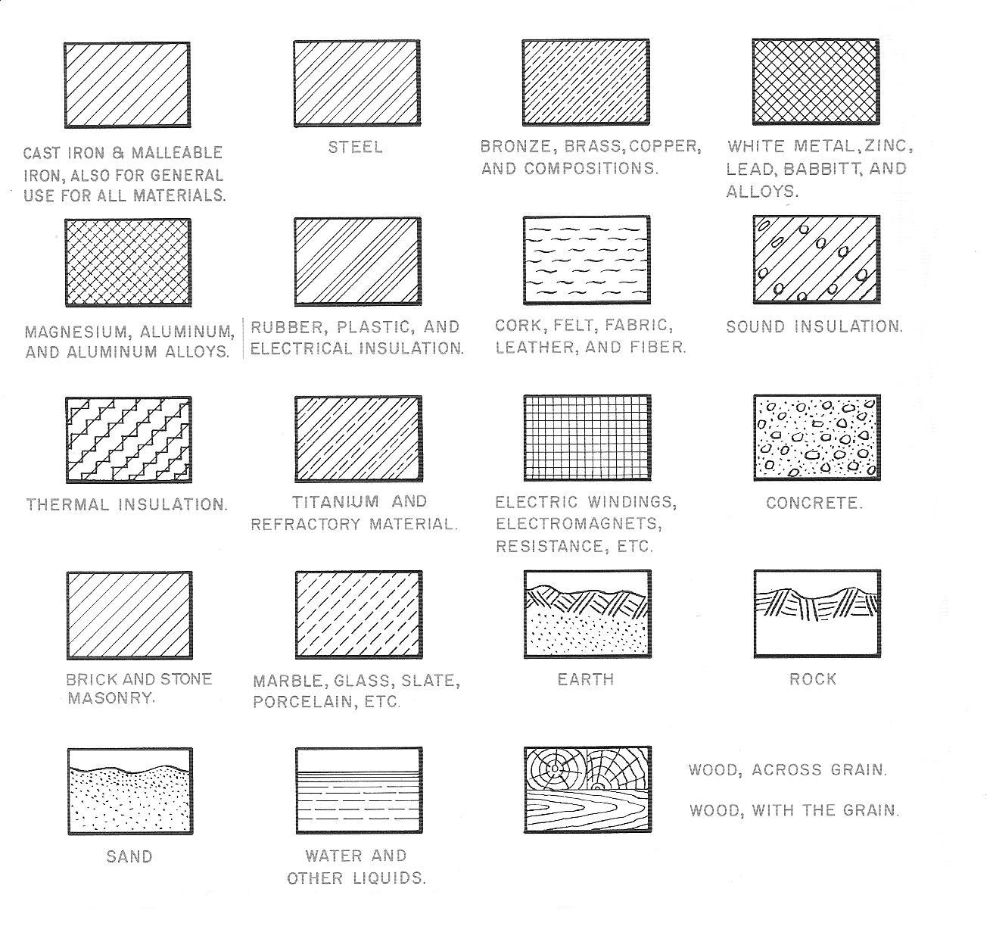

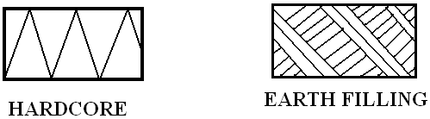

**Electrical materials symbol**

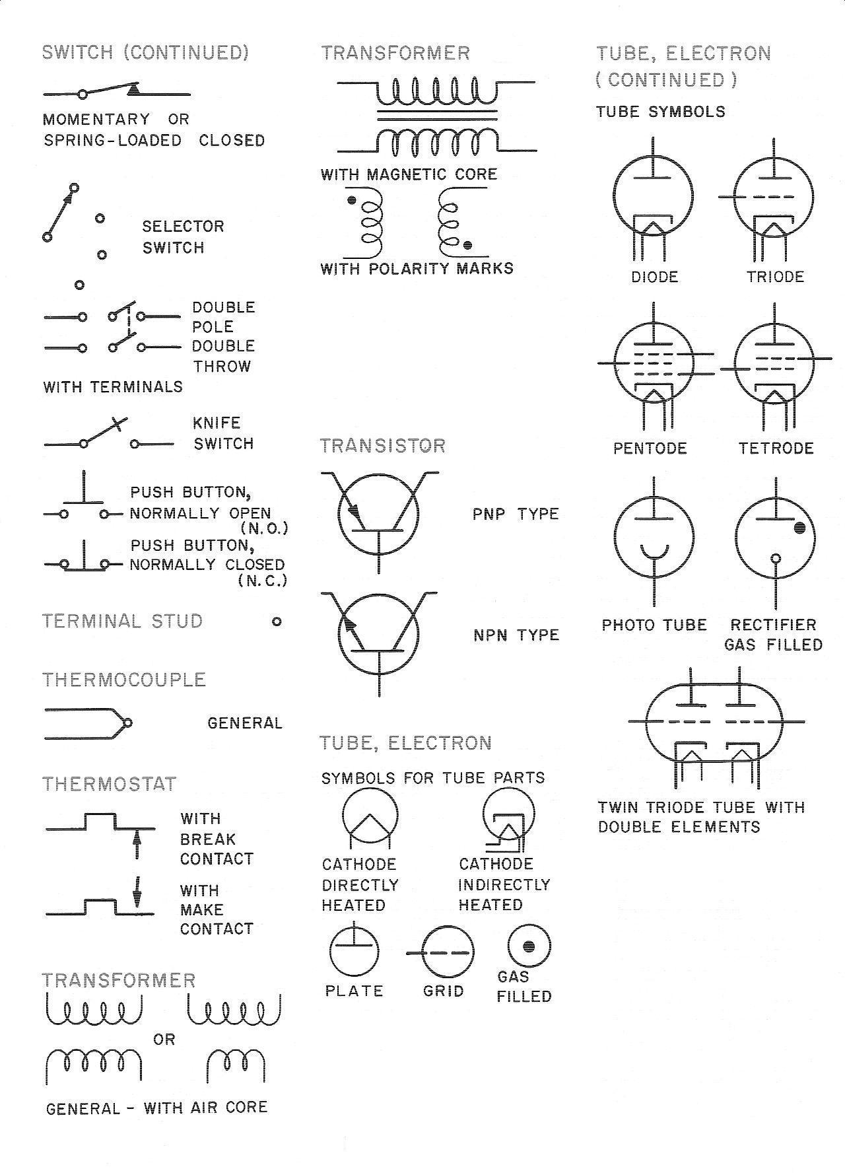

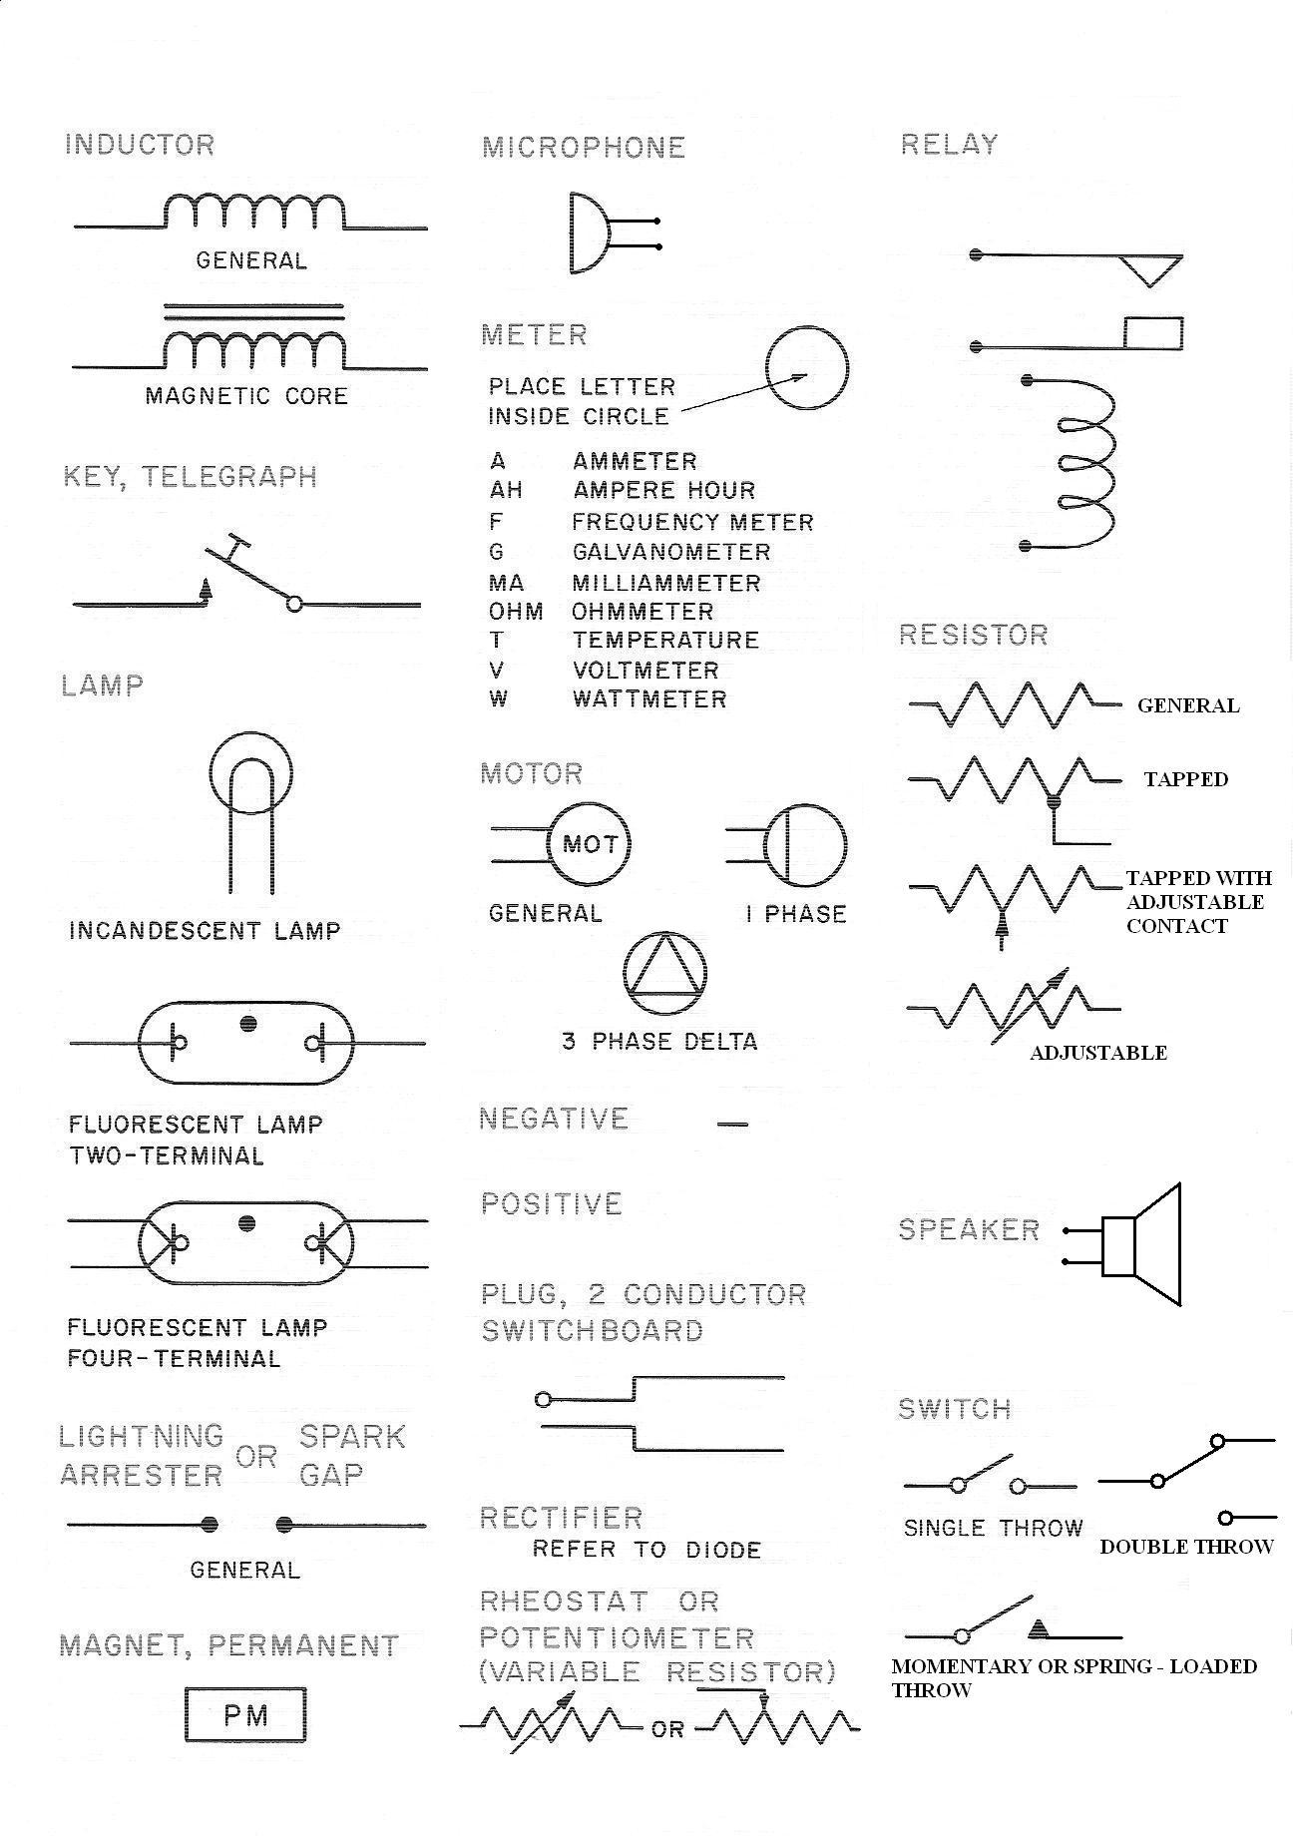

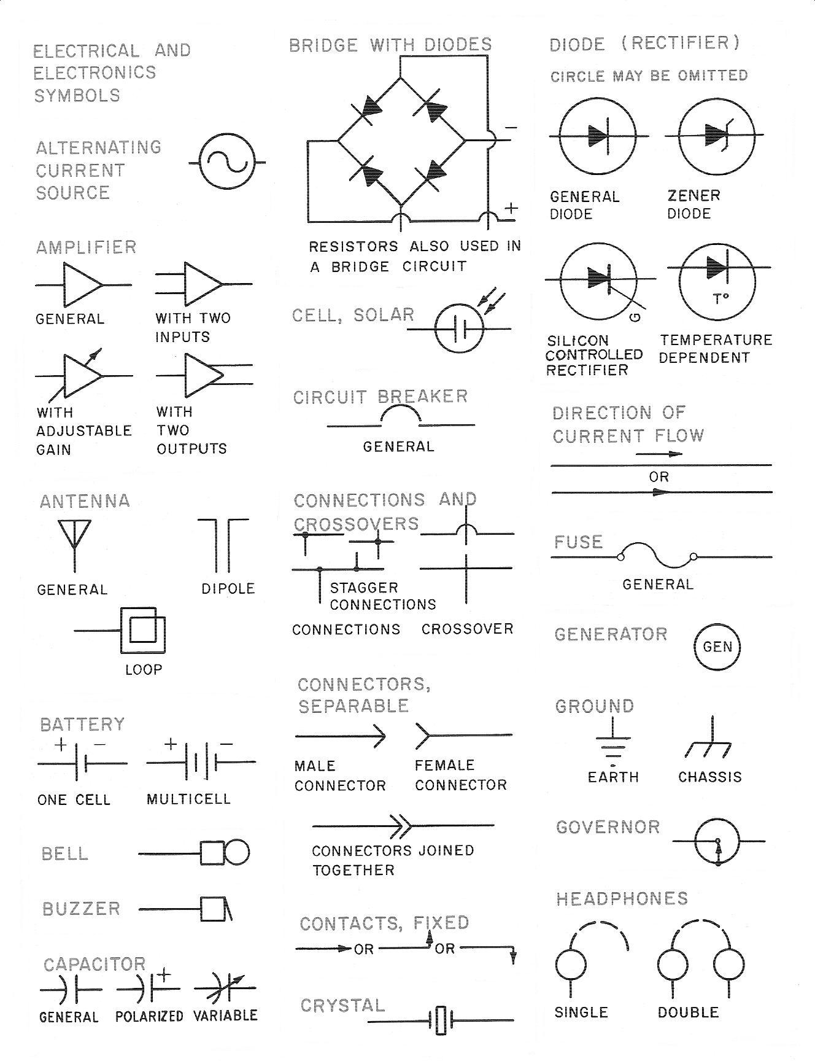

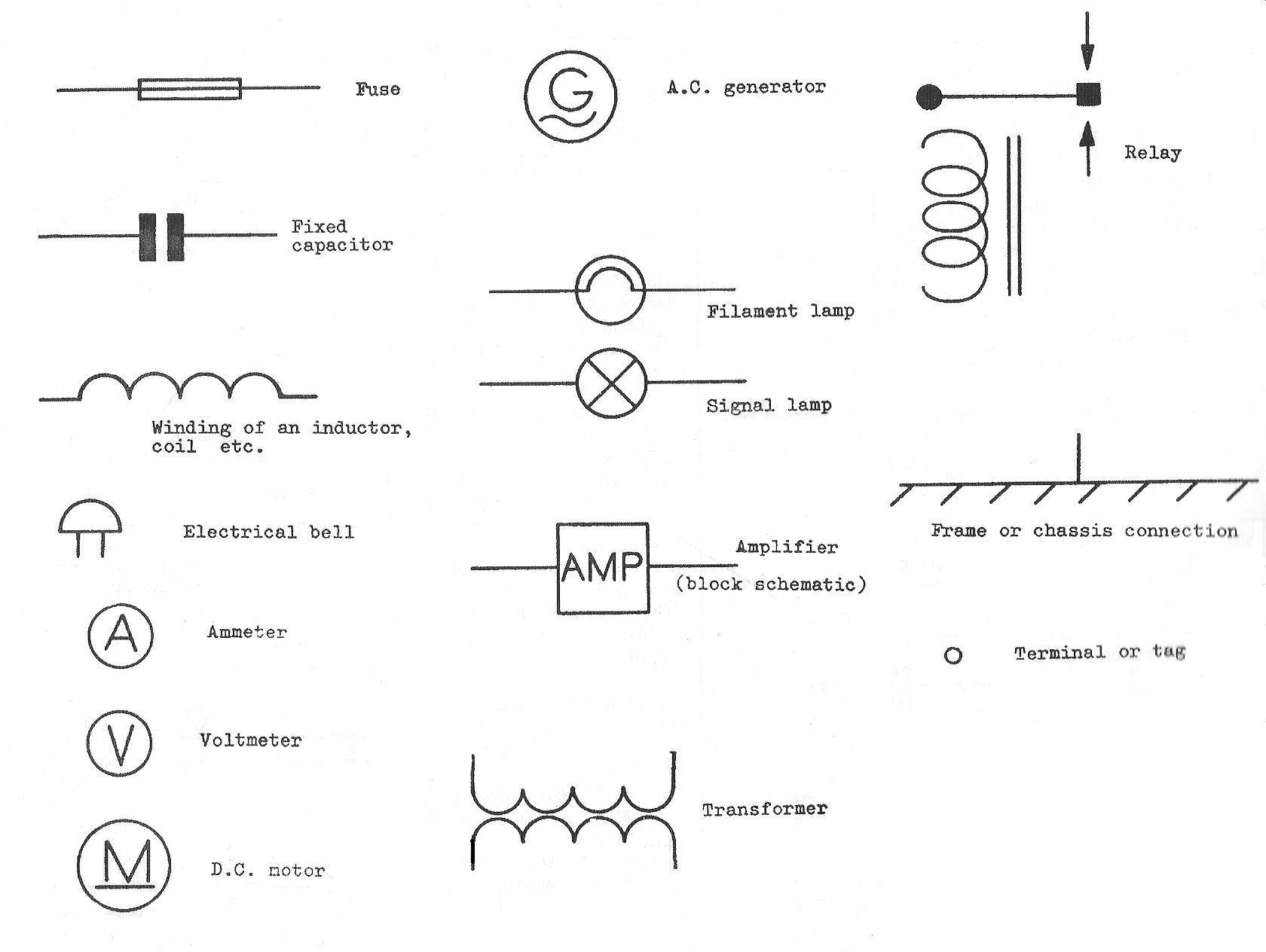

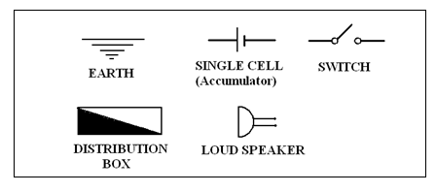

**Plumbing / piping symbols.**

Plumbing symbols: The tables below show examples of plumbing symbols used in engineering drawing.

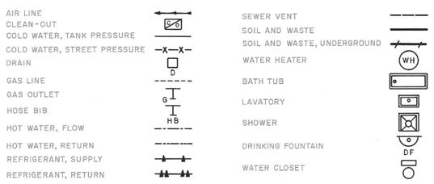

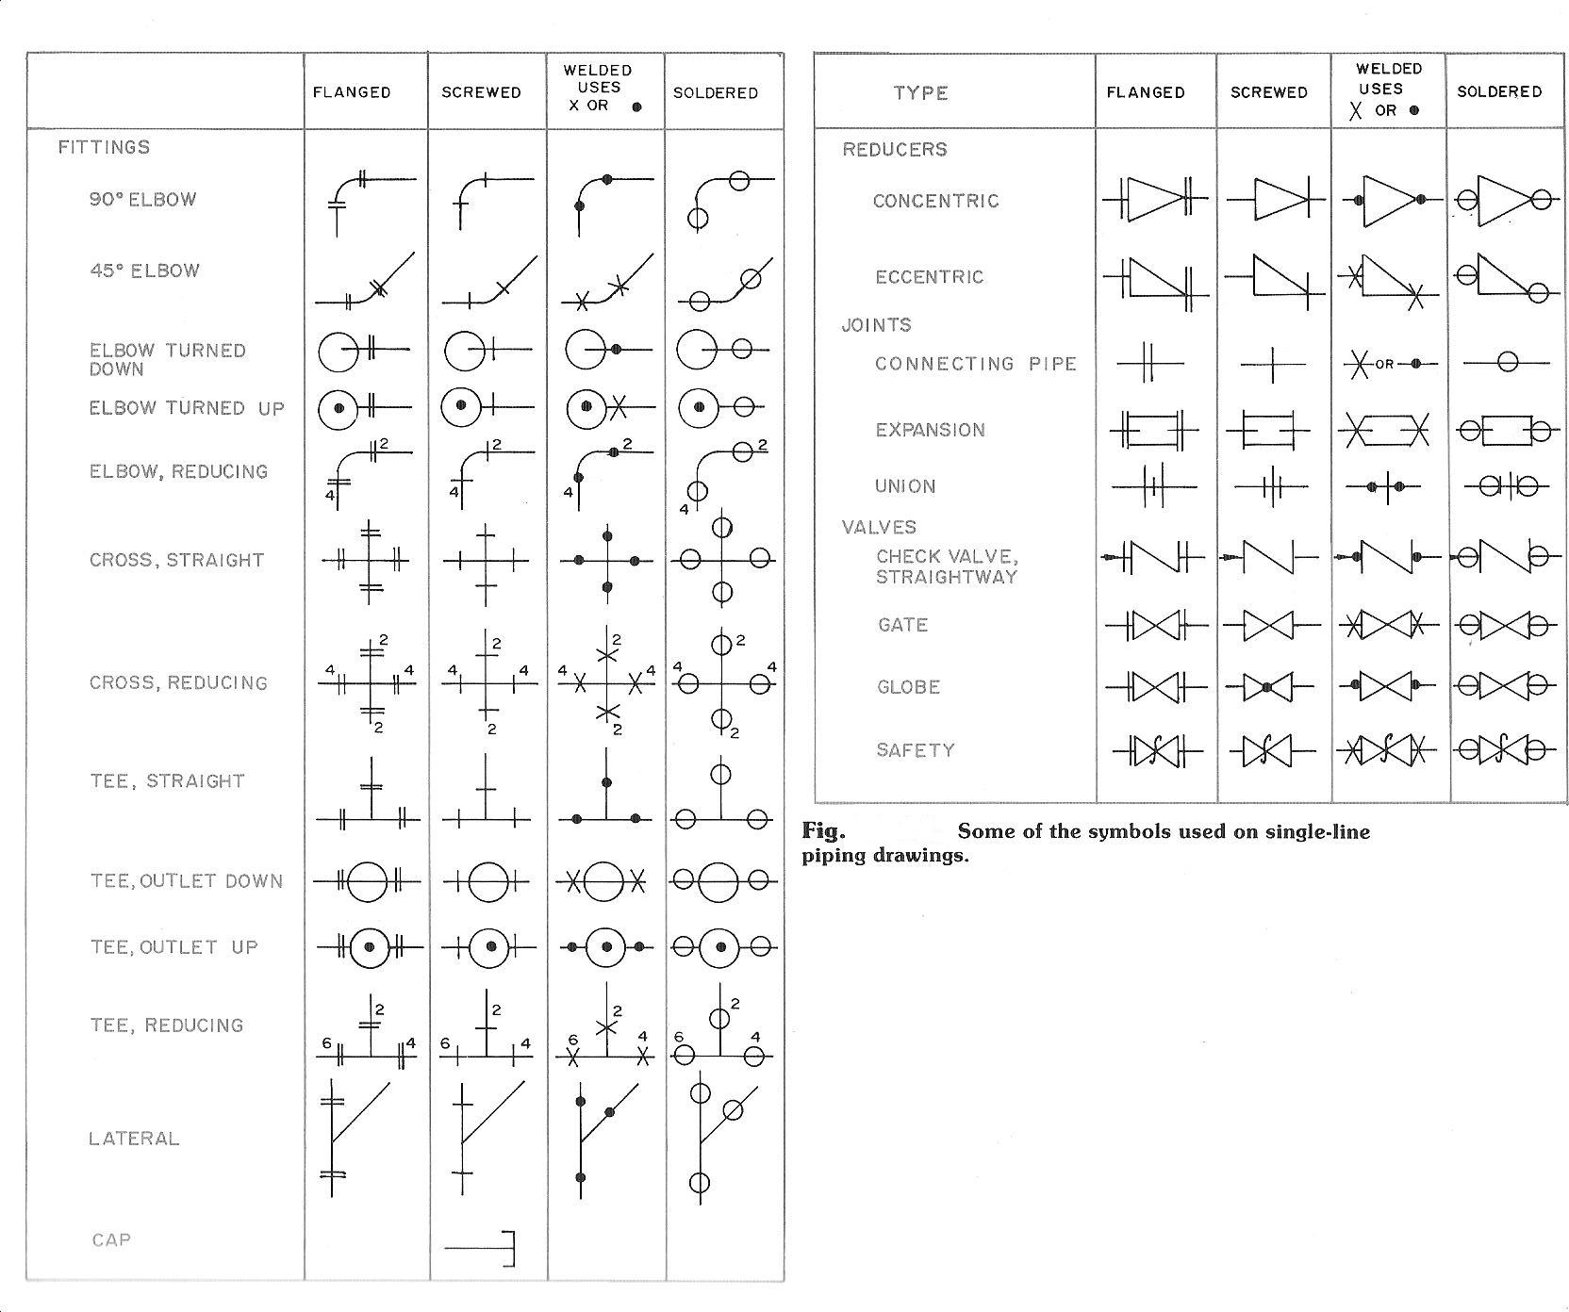

**Evaluation questions**

1. Draw the conventional symbol of the following items: Kitchen sink, Water closet, Shower,Wash hand basin.

2. Draw the conventional symbol of the following items: Bath tub, Gate valve, Wood, Union valve and a reduced

Elbow, Glass, Rubber.

**Reading assignments**

Drafting technology by W. Spence pages 541-542, 680.

**Weekend Assignment**

**Objective**

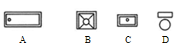

1. Which of the plumbing symbols shown below depicts a water closet?

2. What is the name given to the electrical symbols shown below? A. Colour meter. B. Distribution box. Fuse box.



B. Resistance box.

3. The electrical symbol shown below is called A. capacitor. B. transistor. C. diode. D. triode.

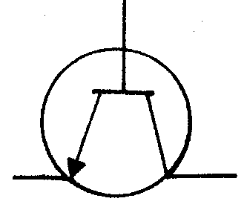

3. Which of the following conventional symbols of electrical components represents a variable resistor?

4. The electrical circuit below shows A. resistor, bell and switch. B. switch, capacitor and bell. C. bell, transformer

and earth. D. earth, battery and switch.

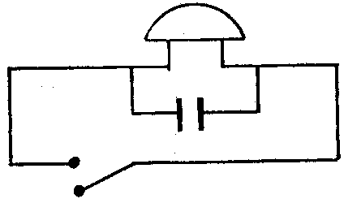

5. What is the name of the symbol shown below?



**Theory**

1. Sketch the diagram of the following electrical components: Lightening arrester, Transformer, Fuse box

2. Draw the conventional symbol of the following items: Kitchen sink, Water closet, Shower and Wash hand basin.

**OTHERS**

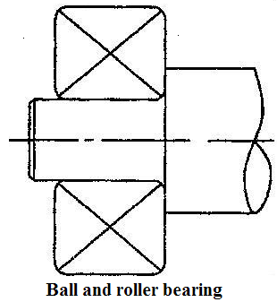

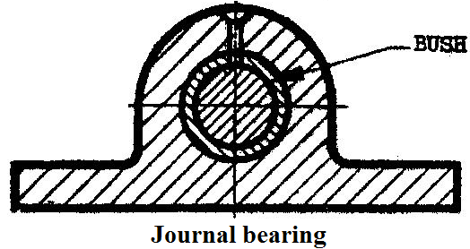

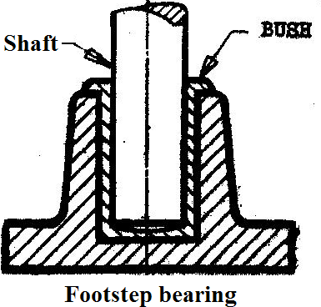

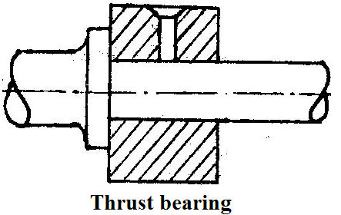

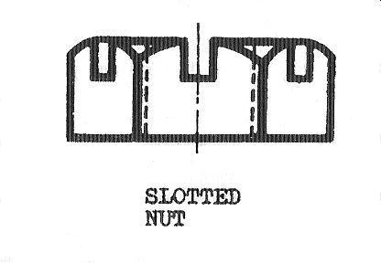

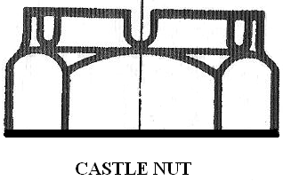

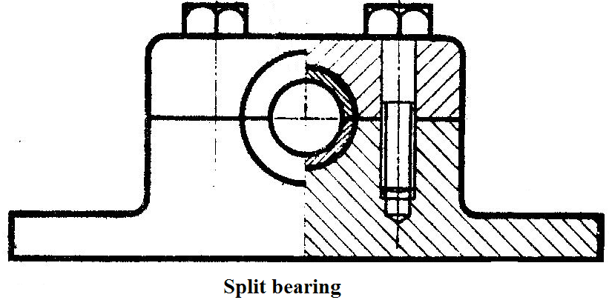

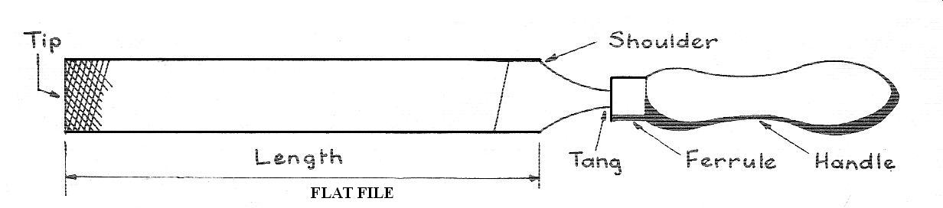

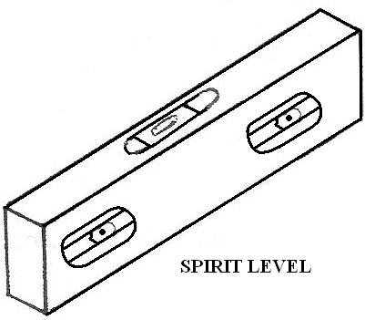

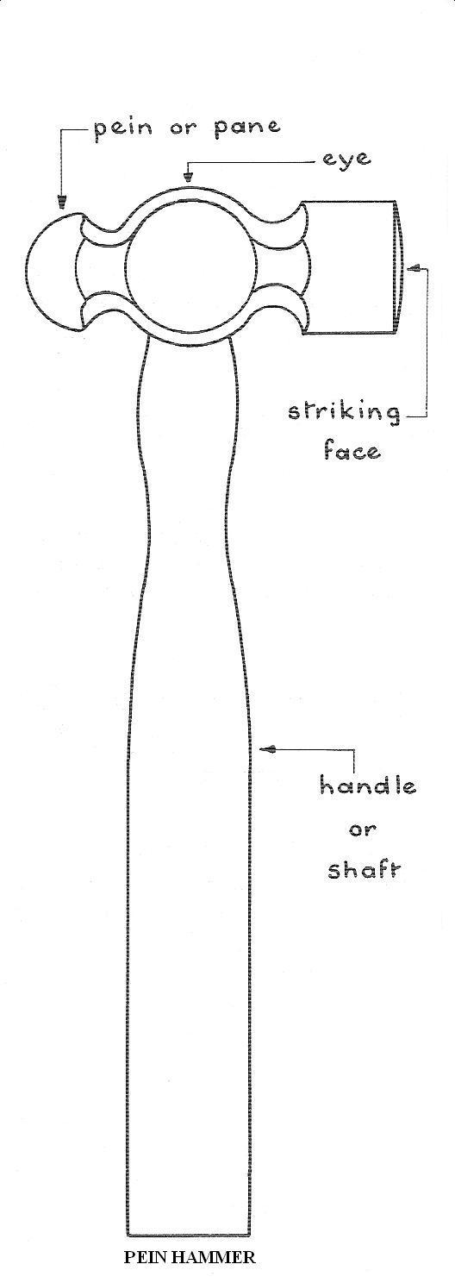

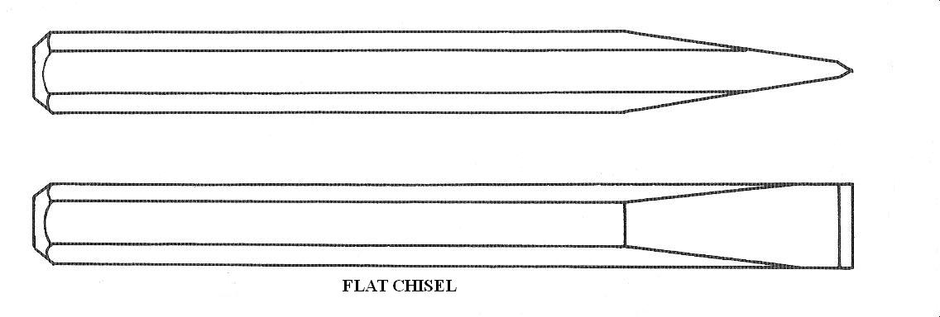

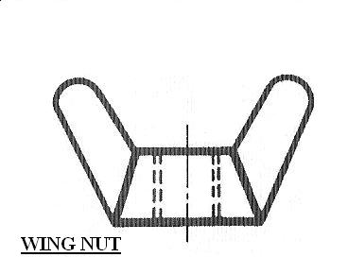

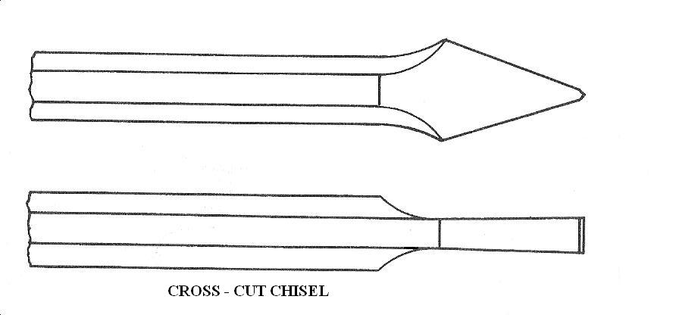

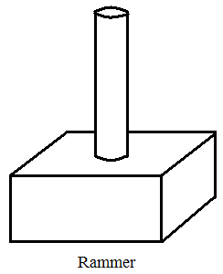

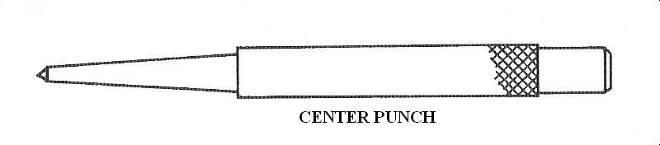

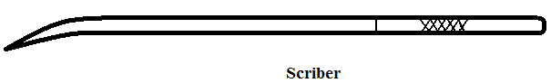

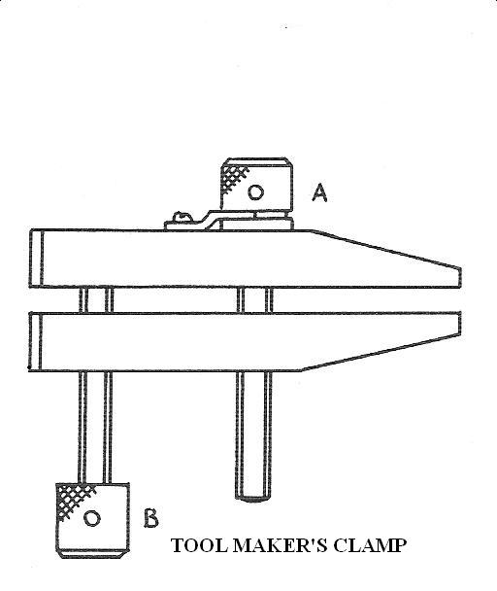

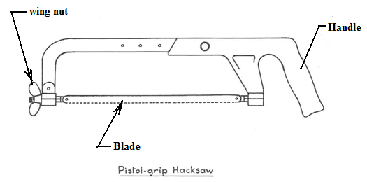

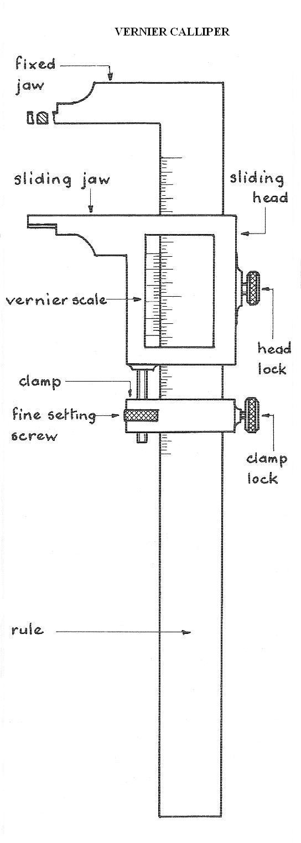

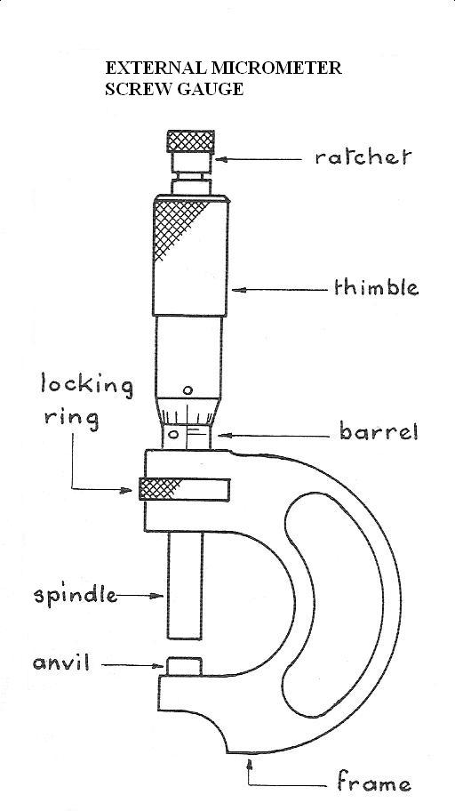

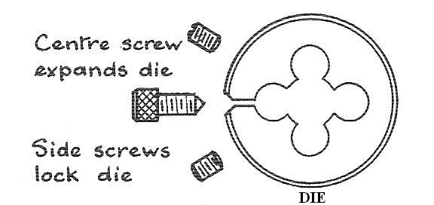

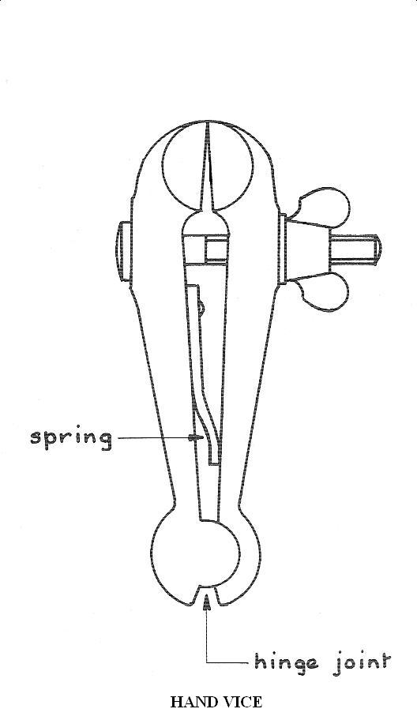

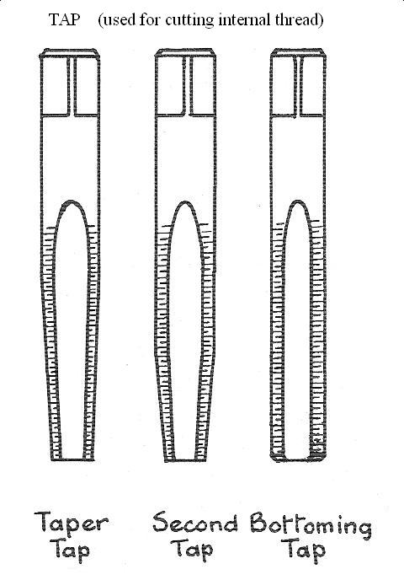

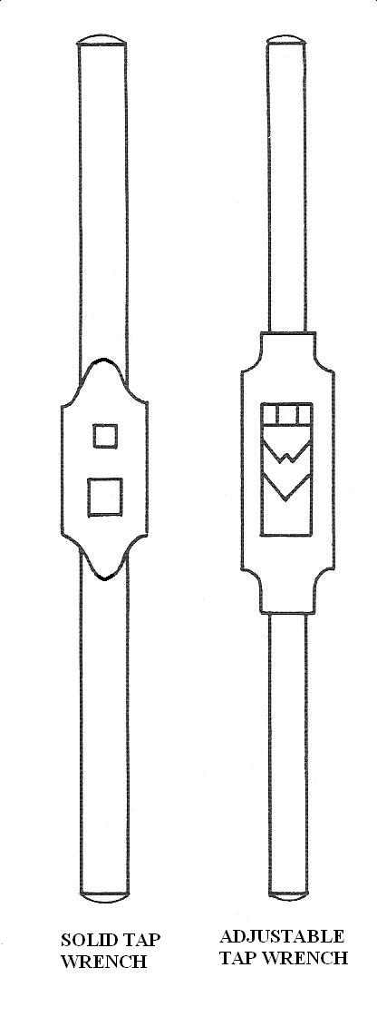

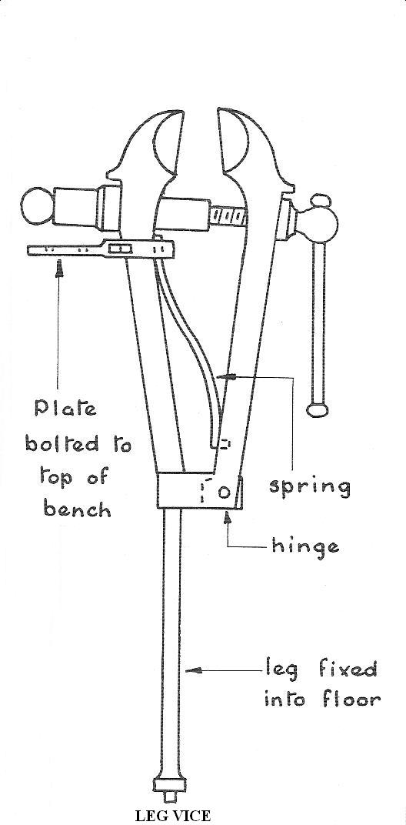

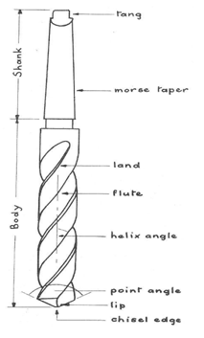

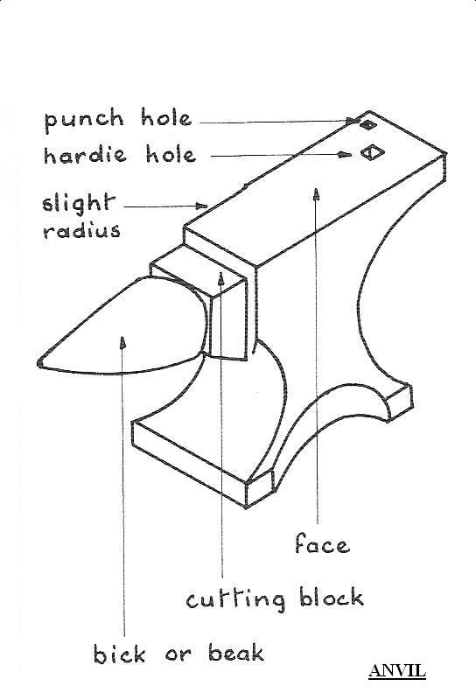

A Twist drill

**ABBREVIATIONS**

Across flats .............................................................................................................A/F.

Center to center .........................................................................................................C/C.

Center line .................................................................................................................CL.

Countersunk ...............................................................................................................CSK.

Counterbore ............................................................................................................... C’BORE.

Pitch circle diameter ..................................................................................................PCD.

Undercut ..................................................................................................................... U’CUT.

Spotface ..................................................................................................................... S’FACE.

Standard ......................................................................................................................STD.

Square (preceeding a dimension ) .................................................................................

Diameter ( preceeding a dimension) ............................................................................ **ø**

Square (in a note) ..........................................................................................................SQ.

Taper, on diameter or width ..............................................................................

Specification ................................................................................................................SPEC.

Material........................................................................................................................ MATL.

Drawing .....................................................................................................................DRG.

**WEEK SEVEN**

**Topic**: **Blue print**

**Content:**

(i) Meaning of blue print.

(iii) How to read blue print.

**Meaning of blue print**

Blueprints are 2-dimensional architectural design drawings that indicate the size of a planned building, the materials to be used in its construction, and the placement of its features. Architects and Engineers use blueprints and written specifications to communicate necessary details with construction workers. Learning to read blueprints is essential not only for construction workers but also for the people who hire architects to draft blueprints, so that they can make more informed decisions on construction and renovation projects.

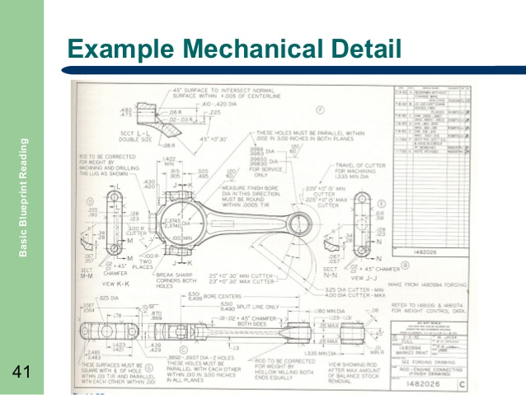

**Evaluation questions**

1. Define blue print.
2. State the importance of blue print in consruction.

**How to read blue print**

1. **Read the title block.**

These often appear at the beginning of any blueprints. If you are involved in any serious construction work, you will want to make sure to read it all thoroughly.

* + The title block's first section lists the blueprint's name, number, as well as the location, site, or vendor.[ If the drawing is part of a series this information will also be listed. This section is largely for filing and organizational purposes.
  + The second section comprises bureaucratic information. Approval dates and signatures are located here. If you find a blueprint that interests you and want to know more, this information can be invaluable.
  + Section three of the title block is the list of references. This lists all other drawings that are related to the building/system/component, as well as all blueprints that were used as reference/inspiration. Similar to the second section this can be incredibly helpful if you are to begin your own blueprint.

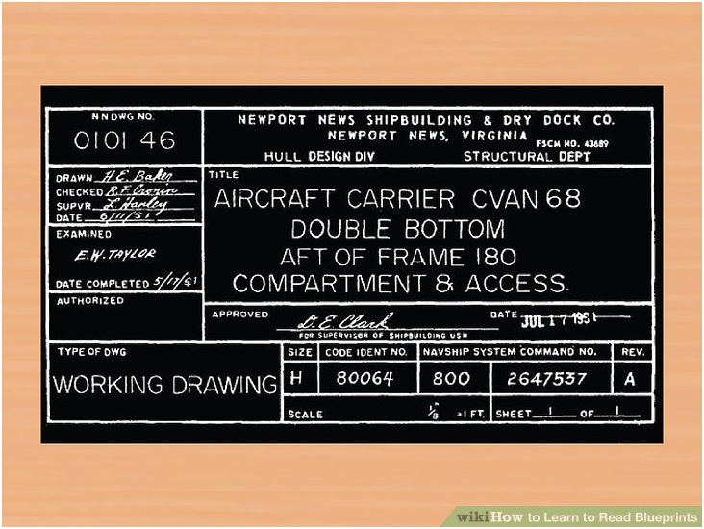

1. **Read the revision block.**

Any time changes to a building/system/component are made, the drawing has to be redrafted. Those changes are listed here.

[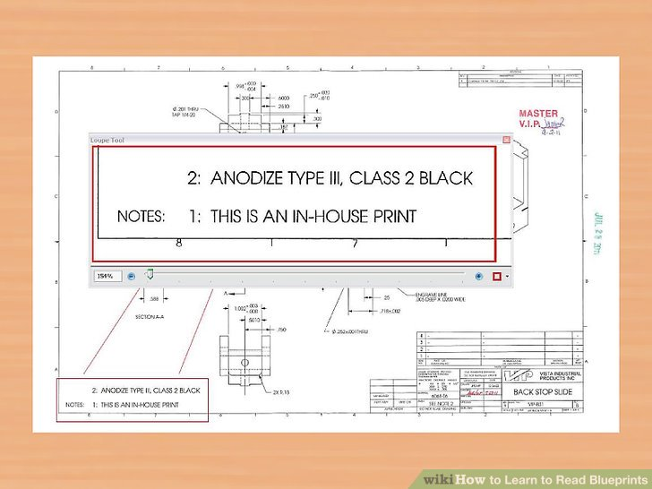](http://www.wikihow.com/Learn-to-Read-Blueprints#/Image:Learn-to-Read-Blueprints-Step-3-Version-2.jpg)

1. **Read the notes and legend.**

In addition to the standard scale, grid, and lines, blueprints are often comprised of other symbols and numbers. In order to fully comprehend the specific blueprint you're working with, be sure to learn those symbols by reading through the legend. The notes will reveal any specifications or information the designer thinks will aid in understanding the drawing.

* + For projects that actually begin construction it is even more important to read the notes. It's possible practical information like, "Do not begin working until 8am," will be listed.

1. **Determine the view.**

With 2D blueprints, there are three common perspectives: plan, elevation, and section.[[2]](http://www.wikihow.com/Learn-to-Read-Blueprints" \l "_note-2) Understanding which one of these is being employed is an important first step to reading any drawing.

* + Plan: A bird's eye view of planned work. Usually this is done on a horizontal plane at 30" above the floor. This perspective allows precise mapping of width and length.
  + Elevation: A view of planned work from the side. These drawings are usually oriented from the north, east, west, or south. Composing an elevation map allows for detailed planning of height dimensions.
  + Section: A view of something as if it were cut through. This perspective is generally imaginary, and is used to show the inner workings of how something will be built.

[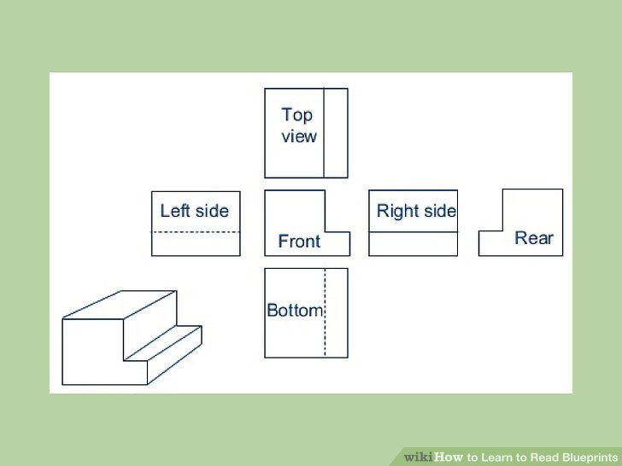](http://www.wikihow.com/Learn-to-Read-Blueprints#/Image:Learn-to-Read-Blueprints-Step-4-Version-2.jpg)

1. **Establish the scale in your mind.**

Blueprints are scaled down representations of things like houses, underground piping, and power line. To ensure proper construction, always use precise measurements. The scale sets a rule for the entire drawing, saying what measurements on the drawing are equal to in real life. For example 1/8" = 1' (one eighth inch equals one foot).

* + Architectural scales are used for the construction of building exterior and interiors; for establishing doors, windows, and walls. Many are presented in fractions: 1/4" = 1' (one-fourth inch equals one foot), 1/8" = 1' (one-eighth inch equals 1 foot). [[3]](http://www.wikihow.com/Learn-to-Read-Blueprints" \l "_note-3)
  + Engineer scales, or civil scales, are used for public water systems, roads and highways, as well as topographical endeavors. They use whole-integer ratios like 1" = 10' (one inch equals 10 feet) or 1" = 50' (one inch equals fifty feet).

[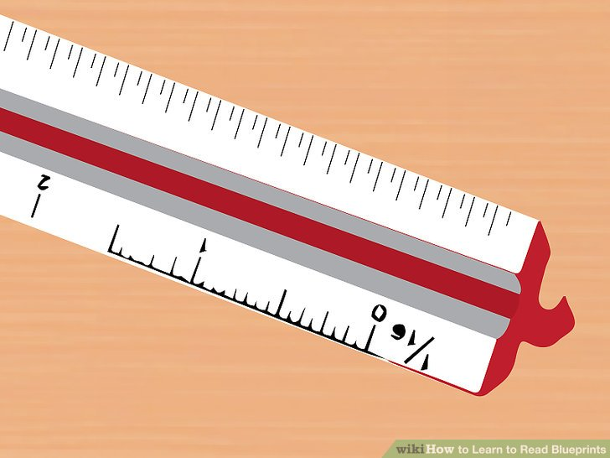](http://www.wikihow.com/Learn-to-Read-Blueprints#/Image:Learn-to-Read-Blueprints-Step-5-Version-2.jpg)

1. **Inspect the grid system.**

Along the horizontal and vertical edges of a blueprint, drawers often fix a simple grid system with numbers on one axis and letters on the other. This allows anyone reading the plans to reference the location of a point or object within the drawing. For example,

If you are looking over the drawings with a team or partner and can't physically point to the location

you're discussing, grid systems are very useful. This could be the case if you working online from

different locations, or the other person/people simply isn't in the room with you.

[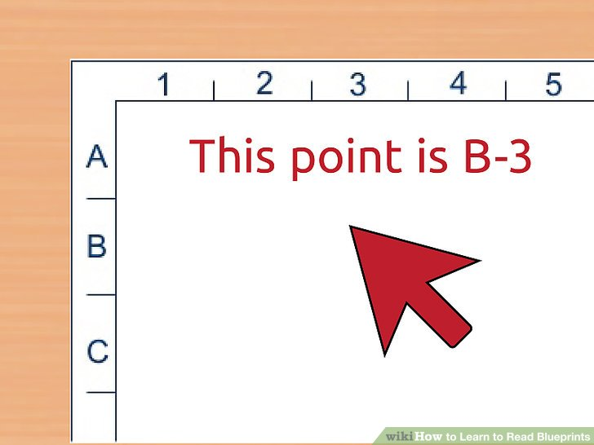](http://www.wikihow.com/Learn-to-Read-Blueprints#/Image:Learn-to-Read-Blueprints-Step-6-Version-2.jpg)

1. **Locate any doors and windows.**

On blueprints, doors look like larger gaps between walls. There will also be a curved line with a mock door extended in or out of the door frame. This reveals which way the door will swing upon construction. Windows are likewise identified by the end of object lines and will typically be represented realistically to show their size.

[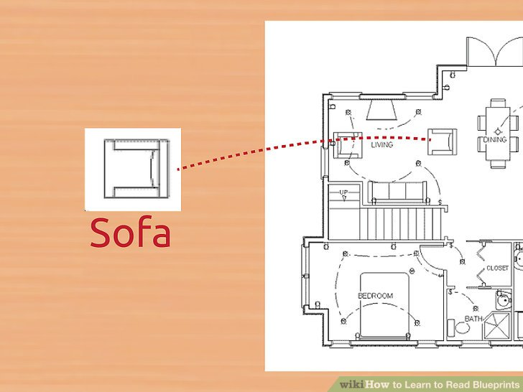](http://www.wikihow.com/Learn-to-Read-Blueprints#/Image:Learn-to-Read-Blueprints-Step-8.jpg)

1. **Identify any appliances.**

Fridges, toilets, sinks, ovens, stove-tops burners, and the like will be represented by simplistic representations that are readily recognizable. Take the time to consider whether they are located in an area where you want them. Although it may seem like their placement comes second the establishing walls, they can end up playing a more important role in deciding on design specifications.

**Evaluation questions**

State five areas to be focused on while reading blue print.